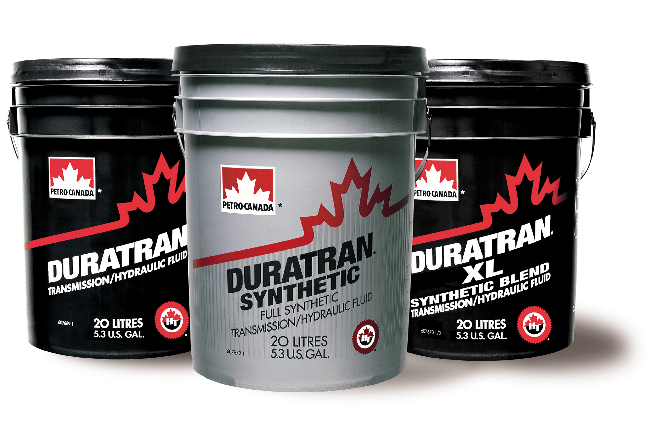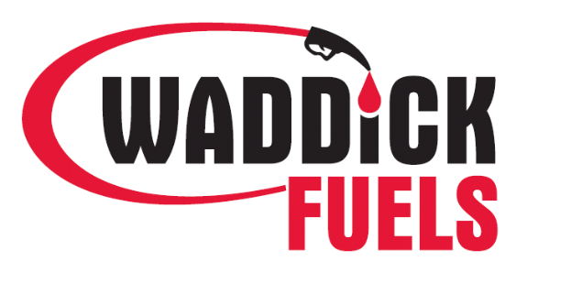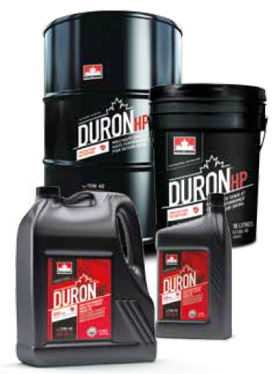
Chatham (519) 354-0110 ∙ Essex (519) 776-5248 ∙ Bothwell (519) 695-2121 ∙ Petrolia (519) 882-2420

Agriculture Winter Lubricant Promotion
February 1st, 2021 – April 15th, 2021

Backed by our Petro Canada No Nonsense Warranty, Waddick Fuels are pleased to offer to the agriculture industry the following OEM approved discounted products. We would like to thank all of our past and current customers on their commitment to a brand that they trust, year over year. moving forward we will encourage all of our customers to be safe in 2021 and we at Waddick Fuels look forward to hearing from you soon at one of our four locations. Stop in or give us a call to place your order!

Minimum Order Requirement of 100 L to obtain Sale Pricing

1 L. Bottle 4 & 10 L. Jug 20 L. Pail 205 L. Drum
Duron HP 15W40 – CK4 $ 3.79 / L. $ 3.59 / L. $ 3.29 / L. $ 3.19 / L.
Duratran (Tractor Hyd.) $ 3.59 / L. $ 3.29 / L. $ 3.19 / L.
Duratran XL (Tractor Hyd. – Syn. Blend) $ 4.69 / L. $ 4.59 / L. $ 4.19 / L.

all other Duron products along with Duratran Synthetic and All Hydrex AW & MV products are Discounted $0.40 / L. from our Current Posted Price

** Bulk oil deliveries are excluded from the promotion**
**duron hp 15W40 & duratran bulk customers in the agriculture industry will be offered a special price during this promotion**
** All package products less than 30 l are subject to ehc (environmental handling charge) **

200 – 400 Liters of lubricants - receive a Waddick Fuels labelled item

400+ Liters of lubricants - receive a Waddick Fuels labelled item
AND
$25.00 Petro Canada Gas Card
OR
5 L of Aspen product
(Aspen 2 - 50:1 Ethanol Free High Octane Premix Fuel; Apsen 4 – Ethanol Free High Octane Fuel)



